
Sec 5.9 – Trigonometry & Regression
Other Regression Models Name:
Common Function Models:
LINEAR | QUADRATIC | CUBIC | QUARTIC
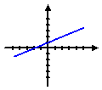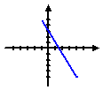 | 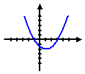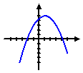 | 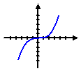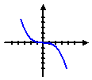  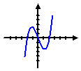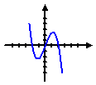 | 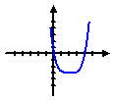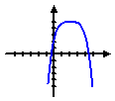  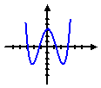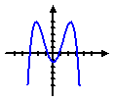
EXPONENTIAL | LOGARITHMIC | LOGISTICS | SINUSOIDAL
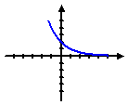  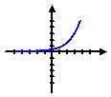 | 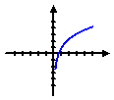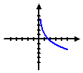 | 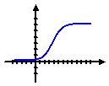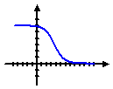 | 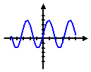
- Which model do you think is the most appropriate for the following data sets?
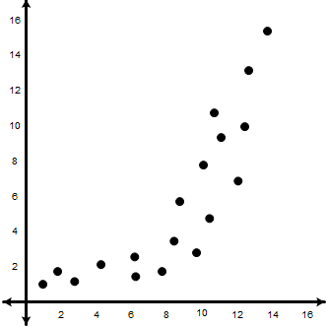
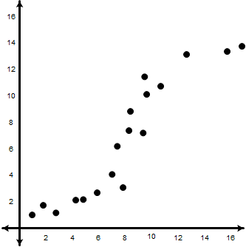
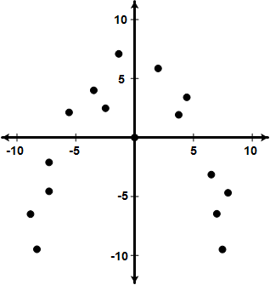
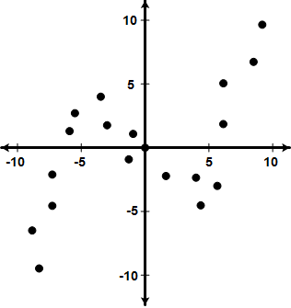
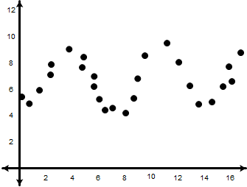

Model:
Model:
Model:
Model:
Model:

- Determine which model would be best for each of the following data sets and then determine an equation.
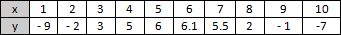
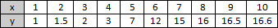

Model:
Equation:
Model:
Equation:

Make a graph of the data on your calculator and on the grid.
Enter the data from the chart into L1 and L2
    - Press
    - If there is OLD data already in the lists that needs to be cleared press the up arrow, , to highlight L1 and then press to clear out the old data. Do the same for L2 if it has OLD data that needs to be cleared.
    - Next, enter all of the data in L1 and L2.
Select each of the following options by moving your cursor to each and Pressing ENTER .
    - After entering the data, press and select all of the options shown in the screen at the right. To do this move the cursor to the appropriate option ( , ,)and press . To change the Xlist to L₁ if needed move the cursor to Xlist and press and to the Ylist and press .
    - Finally, press . To make further adjustments to the graph window press .
    - Additionally, you can type the equation you calculated earlier in the to see the scatter plot and regression equation

Student Worksheets Created by Matthew M. Winking at Phoenix High School SECTION 5-9 p.75

- Make a scatter plot of the length of daylight by day number for Houston on the blank grid.
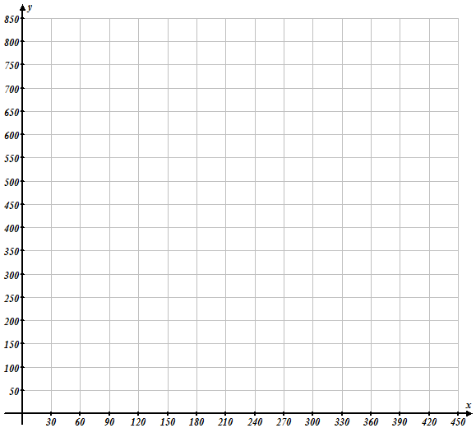
(Length of Daylight for Cities).
To make the graph easier, make January 1 = Day 1 and December 31 = Day 365. In addition, graph the length of daylight in terms of minutes.
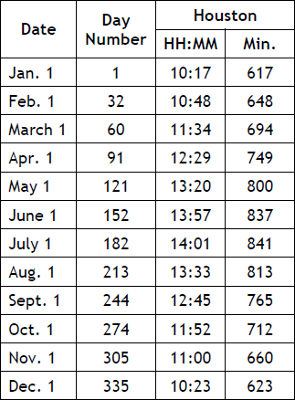

- Continue plotting data points for the second year as they would repeat beginning with the first day of the second year of 366 would again have the length of a day of 617 minutes (Day 397, 648 min)

- Which mathematical model would be most appropriate?

- Enter the data into the stat lists of your graphing calculator. Use the calculator to make a scatter plot of the length of daylight by day number for Houston.
Enter the data from the chart into L1 and L2
    - Under the Stat menu, press. (This just resets the stat menu.)
    - Press
    - If there is OLD data already in the lists that needs to be cleared press the up arrow, , to highlight L1 and then press to clear out the old data. Do the same for L2 if it has OLD data that needs to be cleared.
Select each of the following options by moving your cursor to each and Pressing ENTER .
    - Next, enter all of the day numbers in L1 and the day lengths in L2.
    - After entering the data, press and select all of the options shown in the screen at the right. To do this move the cursor to the appropriate option ( , ,)and press . To change the Xlist to L₁ if needed move the cursor to Xlist and press and to the Ylist and press .
    - Finally, press . To make further adjustments to the graph window press .

- Use your calculator to generate a sinusoidal regression model. Record the equation (round values to the nearest hundredth) in the Summary Table at the end of this activity sheet. Factor the value of b from the quantity (bx – c) and include that form of the equation as well.
Return to the home screen by pressing and then to calculate the Sinusoidal regression press .
Scroll down to choice “C:SinReg”

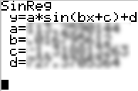
$y= ______ sin\left( _______x+_______\right)+_______$
c
d
b
a

- Based on the model predict the length of day 185 (The 4th of July).

Student Worksheets Created by Matthew M. Winking at Phoenix High School SECTION 5-9 p.76


- A company in California is test marketing a new line of lipsticks. The lipstick only costs the company $0.90 to make due to the volume production. The company located several different cities with approximately the same demographics and sold the exact same lipstick at different prices. They wanted to know which price would yield the largest profit. The following table shows the prices at which they were sold and the number sold at that price over a period of 3 months.

Cost | $3.00 | $4.00 | $5.50 | $7.00 | $8.50 | $10.00
Number Sold | 19 | 59 | 91 | 117 | 101 | 48

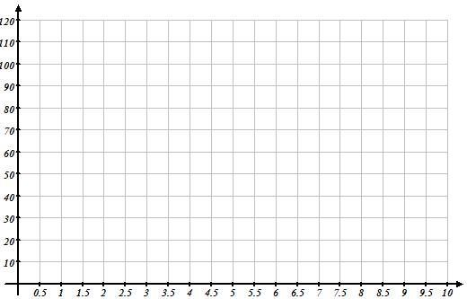

- Make a Scatter Plot.

  - Draw a trend line or curve if more appropriate.

  - What type of association does the data show? (Is it linear?)

  - Explain why you think the data looks the way it does.

  - The TI-83/84 is capable of calculating quadratic, cubic, and quartic regression equations. Determine an appropriate regression model using the data.

  - According to your model, what might be the suggested number sold if the store charges $9?

  - According to your model, what might be the suggested number sold if the store charges $12?

  - What constraints should be put on your model?

Student Worksheets Created by Matthew M. Winking at Phoenix High School SECTION 5-9 p.77


- A rancher has decided to dedicate a 400-square-mile portion of his ranch as a black bear habitat. Working with his state, he plans to bring 10 young black bears to the habitat in an effort to grow the population. His research shows that the annual growth rate of black bears is about 0.8. Black bears thrive when the population density is no more than about 1.5 black bears per square mile.

After bringing the initial 10 bears. The researcher noticed the following population growth:

Year | 1995 | 1996 | 1997 | 2000 | 2002 | 2003 | 2004 | 2005 | 2007 | 2008 | 2010 | 2011 | 2012
Years after  1995 | 0 | 1 | 2 | 5 | 7 | 8 | 9 | 10 | 12 | 13 | 15 | 16 | 17
Number  of Bears | 10 | 18 | 30 | 148 | 302 | 391 | 465 | 515 | 575 | 580 | 595 | 597 | 598

- Which model would be best?

- Determine a regression model using the calculator.

- What appears to be the maximum population of bears? (Hint: just predict the number of bears far off in to the future and see if it levels out. You could predict the number of bears in 2055 where x = 60)

Student Worksheets Created by Matthew M. Winking at Phoenix High School SECTION 5-9 p.78

